|  |  |
| --- | --- |
| *Pacific Gas and Electric Company* | |
| Release 9.1 Installation Guide | |
|  |  |
|  |  |
| Project | ED AM/GIS |
|  |  |
| Prepared by | Ashish Narasimham |
| Date | 12/9/2014 |
| Version | 1.1 |
| Version Type | Final |

|  |  |  |  |
| --- | --- | --- | --- |
| Revision History | | | |
| Document # | Date | Author | Summary of Changes |
| 1.0 |  | Ashish Narasimham | Initial Document Creation |
| 1.1 | 9th Dec 2014 | Roger Carribine | Minor updates following implementation in gold |

# Introduction

## Purpose

This document is intended to detail the implementation and configuration steps required to implement Release 9.1 Installation Guide. This document describes the various configuration aspects required to complete any manual or automatic patch associated with this release. Each section in this document contains the steps required to patch the system in production.

## Terms Used

|  |  |
| --- | --- |
| OOTB | Out of the box. Unmodified from the commercial version. |
| TFS | Team Foundation Server |

## External Documents

Referenced are any external configuration documents or exports. These are documents that contain more detailed information about configuring a system or documents that can be loaded into an application to perform the configuration detailed in this document.

## List Of Fixes

Below is the list of change requests detailing all fixes for the data model for this release:

|  |  |  |
| --- | --- | --- |
| **Item Number** | | **Title** |
| [17684](http://edappgistfsprd1:8080/tfs/web/wi.aspx?pcguid=15e9a9d1-95cb-4dd0-abfe-5af14ae6201f&id=17684) | | Master TFS Data Model 9.1 |
| [16229](http://edappgistfsprd1:8080/tfs/web/wi.aspx?pcguid=15e9a9d1-95cb-4dd0-abfe-5af14ae6201f&id=16229) | DA Issue: Remove Structure Size domain from Vault Subtype |
| [17223](http://edappgistfsprd1:8080/tfs/web/wi.aspx?pcguid=15e9a9d1-95cb-4dd0-abfe-5af14ae6201f&id=17223) | Remove relationships between Transformer and Switch, Transformer and Network Protector |
| [17686](http://edappgistfsprd1:8080/tfs/web/wi.aspx?pcguid=15e9a9d1-95cb-4dd0-abfe-5af14ae6201f&id=17686) | Change Domain Conductor Insulation - UG " Code "Lead Rubber" to "R&L" |
| [17687](http://edappgistfsprd1:8080/tfs/web/wi.aspx?pcguid=15e9a9d1-95cb-4dd0-abfe-5af14ae6201f&id=17687) | PAR 76087: Add New Pole Height Range Domain to Support Structure subtype "Tower" attribute "Height" |
| [17688](http://edappgistfsprd1:8080/tfs/web/wi.aspx?pcguid=15e9a9d1-95cb-4dd0-abfe-5af14ae6201f&id=17688) | Append Manhole Cover Size to the SubsurfaceStructure’s annotation for Vaults |
| [17689](http://edappgistfsprd1:8080/tfs/web/wi.aspx?pcguid=15e9a9d1-95cb-4dd0-abfe-5af14ae6201f&id=17689) | Bold SubsurfaceStructure and VaultPoly’s Structure Number annotation |
| 17747 | Add Local Office ID to UFM Features |
| 17884 | DCConductor 50 scale anno needs to be smaller |
| 17885 | Update DC Conductor Type Domain |
| 17979 | Clean-up unused UFM features/fields |
| 17981 | UFM Display Fields |
| 17980 | Change Network Protector Annotation Expression |
| 17982 | Add domain value to Duct Shape domain |
| 18258 | Remove GroundingSwitch subtype on TransformerDevice |

## Summary of Steps to Complete Install

Contents

1 Introduction 3

1.1 Purpose 3

1.2 Terms Used 3

1.3 External Documents 3

1.4 List Of Fixes 4

1.5 Summary of Steps to Complete Install 5

2 Open a Database Connection in ArcCatalog 7

3 16229 - DA Issue: Remove Structure Size domain from Vault Subtype 8

4 17223 - Remove relationships between Transformer and Switch, Transformer and Network Protector 9

5 17686 - Change Domain Conductor Insulation - UG " Code "Lead Rubber" to "R&L" 10

6 17687 - PAR 76087: Add New Pole Height Range Domain to Support Structure subtype "Tower" attribute "Height" 11

7 17688 - Append Manhole Cover Size to the SubsurfaceStructure’s annotation for Vaults 12

8 17689 - Bold SubsurfaceStructure and VaultPoly’s Structure Number annotation 13

9 17747 - Add Local Office ID to UFM Features 15

10 17884 - DCConductor 50 scale anno needs to be smaller 18

11 17885 - Update DC Conductor Type Domain 19

12 17979 - Clean-up unused UFM features/fields 24

13 17981 - UFM Display Fields 30

14 Create DC Service Location Feature Class 32

15 Create Relationship Fields and New Subtype for Service Point 35

16 Create Relationship Field For DCRectifier 36

17 Create 1-M Relationship between DC Service Location and Service Pt Table 37

18 Create Relationship Between DC Rectifier and Service Point table 42

19 Create Relationship Between Transformer and DCRectifier 47

20 Configure Relationship Cardinalities 51

21 Remove DC Rectifier->CircuitSource Relationship class 55

22 Add DC to Electric Network 56

23 17980 - Change Network Protector Annotation Expression 57

24 17982 - Add domain value to Duct Shape domain 58

25 18258 – Remove GroundingSwitch subtype on TransformerDevice 59

26 Data Model Version Table 61

27 Known Issues 62

# Open a Database Connection in ArcCatalog

1. Open ArcCatalog.
2. Within the Catalog Tree, expand “Database Connections” and open the active connection for this process. This is the connection that is referenced in the change request associated with this document (EDGIS<DB name in the format X#Y> )

# 16229 - DA Issue: Remove Structure Size domain from Vault Subtype

1. In the Electric Dataset, double click the Subsurface Structure feature class to open the Properties window.
2. Select the Subtypes tab.
3. Select the Vault subtype in the list of subtypes.
4. In the bottom window of fields, scroll to the STRUCTURESIZE field and select it.
5. Unset the domain assigned to the field, scrolling up to the top and selecting “<blank>”.  
   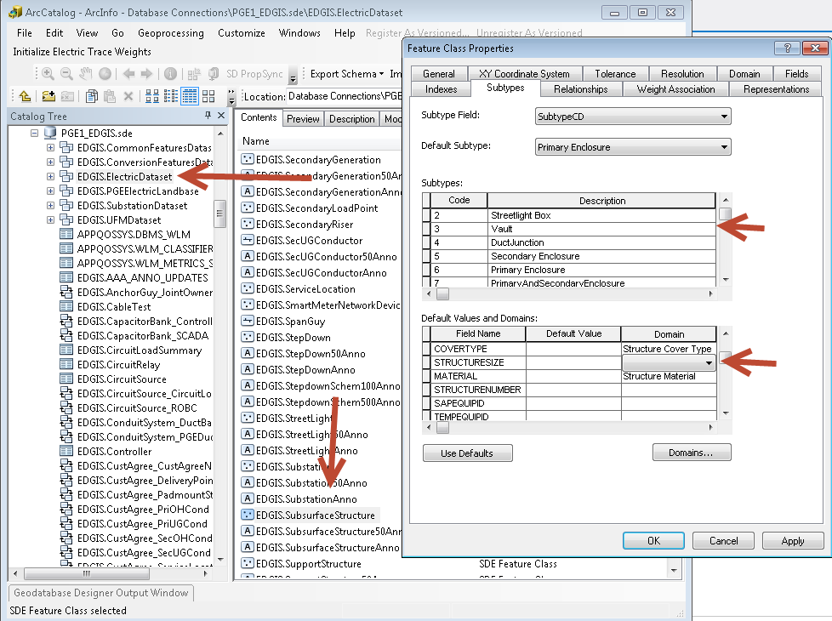
6. Select OK to accept.

# 17223 - Remove relationships between Transformer and Switch, Transformer and Network Protector

1. In the Electric Dataset, locate the “EDGIS.Transformer_Switch” relationship. Right click and select Delete.
2. Select yes when asked to confirm your action.
3. Perform the same action for the “EDGIS.Transformer_NetworkProtector” relationship by right clicking and selecting Delete.  
   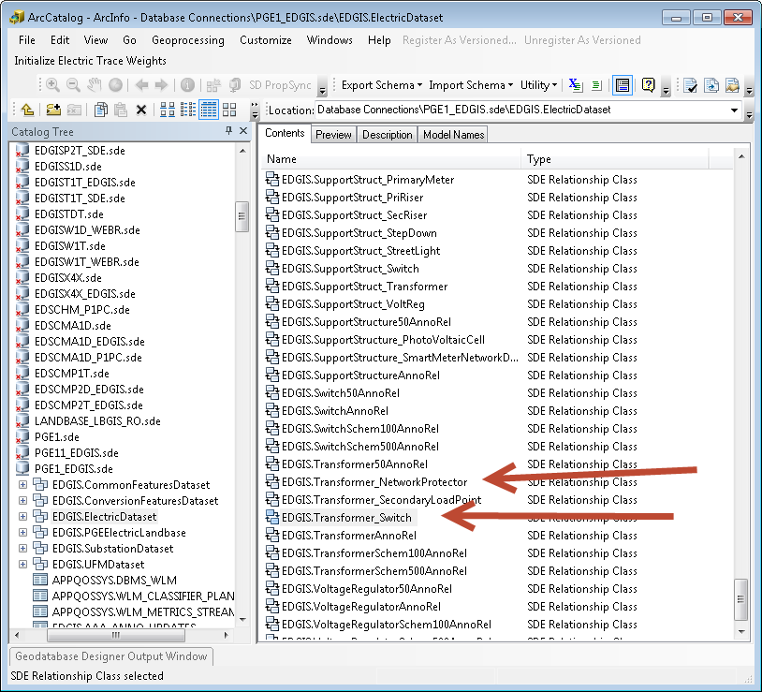

# 17686 - Change Domain Conductor Insulation - UG " Code "Lead Rubber" to "R&L"

1. Right click the database and select Properties.
2. Select the Domains tab and scroll to the “Conductor Insulation – UG” domain.
3. Select it and locate the code/value “LEAD RUBBER”/”LEAD RUBBER”.
4. Change the code to “R&L”.  
   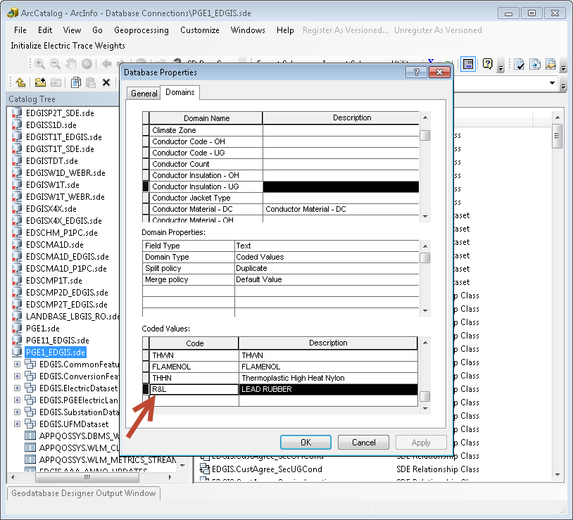
5. Click OK to accept.

# 17687 - PAR 76087: Add New Pole Height Range Domain to Support Structure subtype "Tower" attribute "Height"

1. Right click the database and select Properties.
2. In the Domains tab, scroll to the “Pole Height” domain.
3. Scroll to the bottom and add the following new code/value: 185/185  
   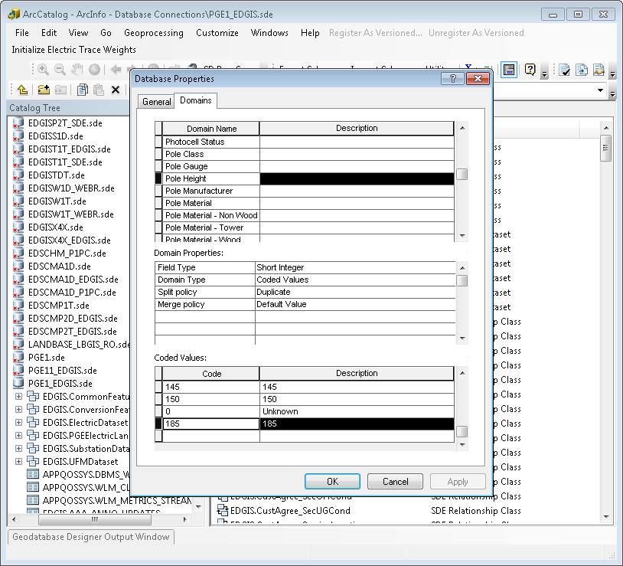
4. Click OK to accept.

# 17688 - Append Manhole Cover Size to the SubsurfaceStructure’s annotation for Vaults

1. In the ElectricDataset, double click the SubsurfaceStructure50Anno object class.
2. Select the Annotation Classes tab and select the “Default” annotation class.
3. Select “Expression…”.
4. Replace the current expression with the following:

Function FindLabel ( [SubtypeCD], [StructureNumber], [MHCoverSize] )

If [SubtypeCD] = "Vault" Then

FindLabel = [StructureNumber] & " -" & [MHCoverSize]

elseif [SubtypeCD] = "DuctJunction" Then

FindLabel = [StructureNumber]

elseif [SubtypeCD] = "Streetlight Box" then

FindLabel = "SL"

End if

End Function

1. Select OK and OK again to accept.

# 17689 - Bold SubsurfaceStructure and VaultPoly’s Structure Number annotation

1. Perform the following steps for each of these four object classes: SubsurfaceStructure50Anno, SubsurfaceStructureAnno, VaultPoly50Anno
   1. Double click the object class in the Electric Dataset.
   2. Select the Annotation Classes tab.
   3. Select the Default annotation class (for VaultPoly select the StructureNumber anno class).
   4. Click the ‘B’ setting to bold the anno.

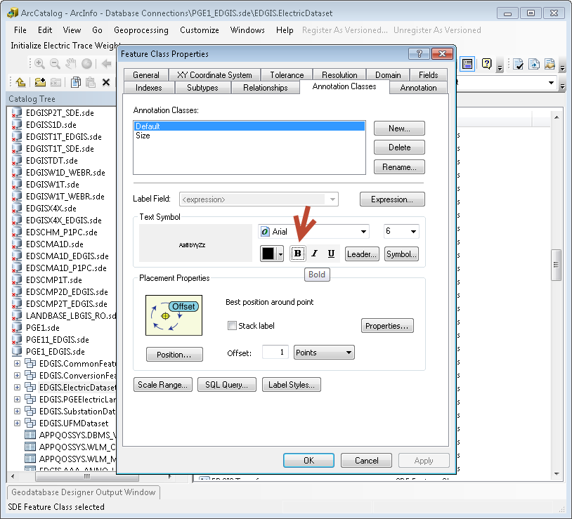

* 1. Click yes when prompted with the warning about existing features:  
     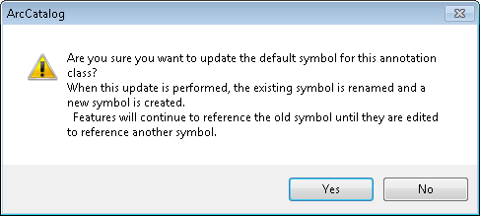
  2. Click OK to accept.
  3. Repeat the above steps for the rest of the anno feature classes listed above.

# 17747 - Add Local Office ID to UFM Features

1. In the Electric Dataset, locate the “EDGIS.ConduitSystem” feature class. Right click and select “Properties…”.

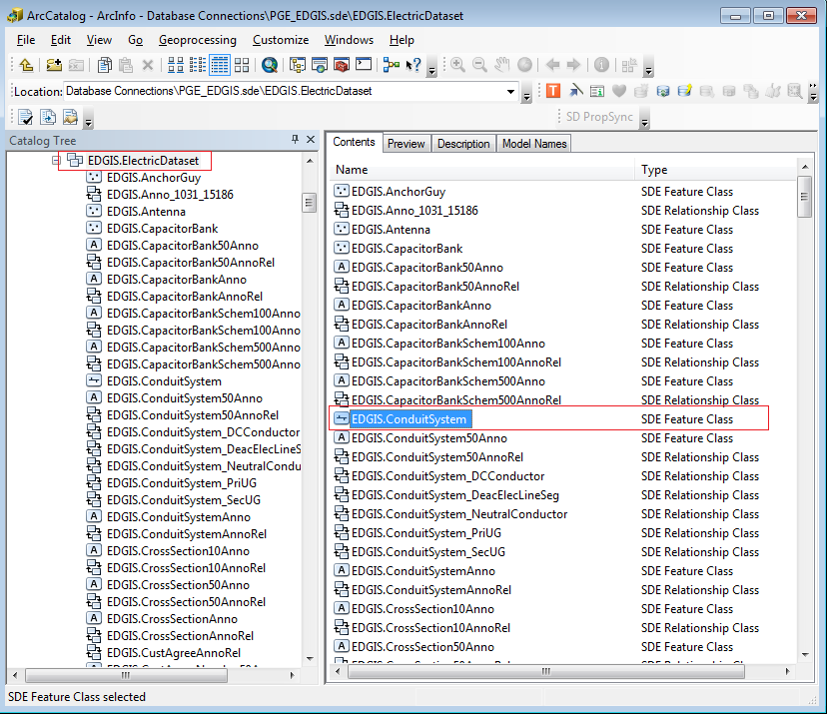

1. In “Fields” tab, scroll to the bottom and add the following field.

Name: LOCALOFFICEID

Data Type: Text

Alias: Local Office ID

Allow Nulls: Yes

Domain: Local Offices

Length: 4

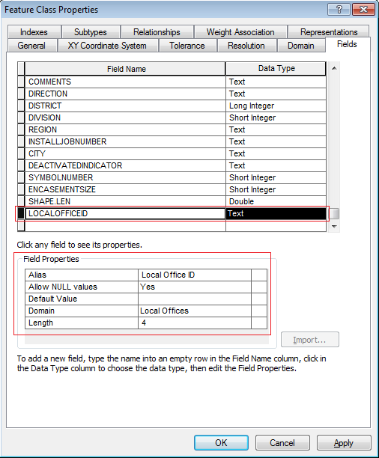

1. Click OK to accept.
2. Right-click on the ConduitSystem feature class and select ArcFM Properties
3. On the Field Model Names tab, assign the PGE_LOCALOFFICE field model name to the Local Office ID field.

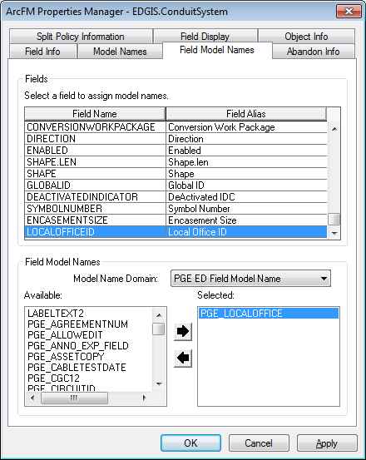

1. On the Object Info tab, select On Feature Create and click Multiple. In the resulting dialog, assign the PGE Populate Local Office AU as show below.

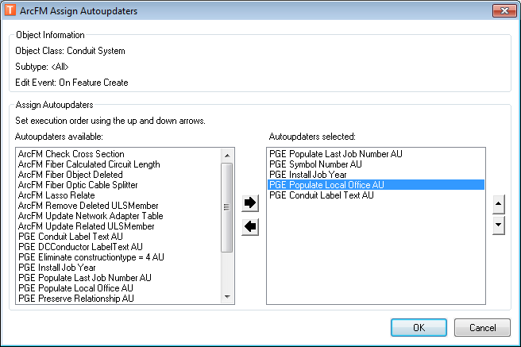

1. Repeat step 6 for On Feature Update.

# 17884 - DCConductor 50 scale anno needs to be smaller

1. In the ElectricDataset, double click the EDGIS.DCConductor50Anno object class.
2. Select the “Annotation Classes” tab and select the “Default” annotation class.
3. Change font size to **6** in the dropdown. Click “Yes” when prompted with the warning about existing features:

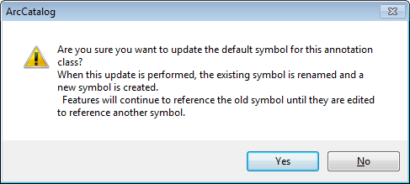

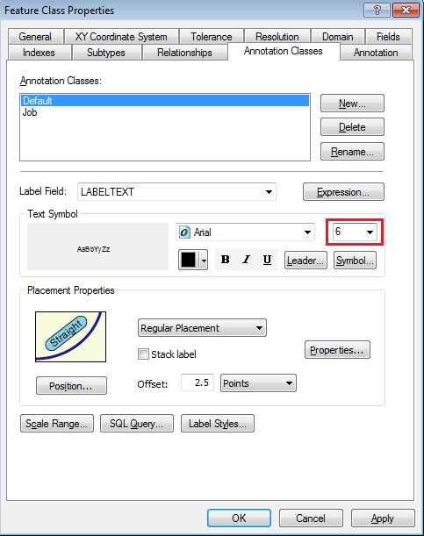

1. Click OK to accept.

# 17885 - Update DC Conductor Type Domain

1. Right click the database and select Properties.
2. Select the “Domains” tab and scroll to the “Conductor Type - DC” domain. Select it and select **all** the code/value as given below:

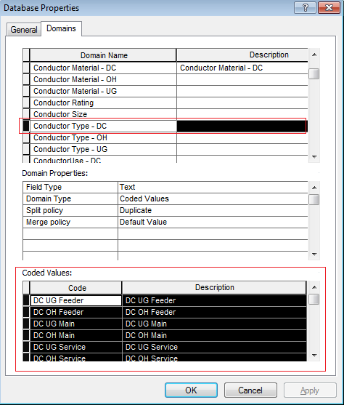

1. Press Delete. (If you face issue with deleting all the code/values in a single go, select one code/value at a time and press “Delete” key. Repeat for all the code/values) **Click Apply.**
2. Add new code:values as given below:
3. OPN: Open Wire
4. SW: Single Wire
5. DPX: Duplex
6. TPX: Triplex

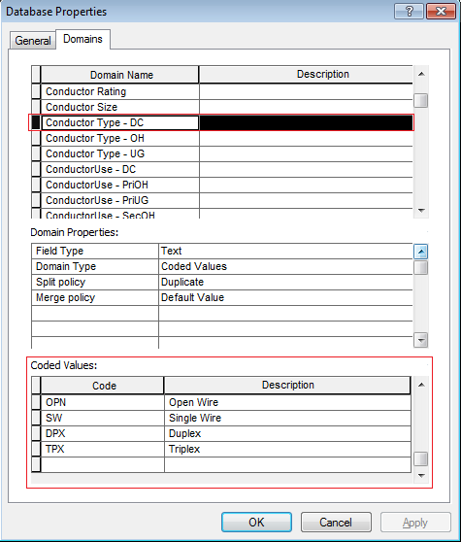

1. Click OK to accept.
2. In the root, locate EDGIS.DCConductorInfo table, right click on it and select “Properties…”.

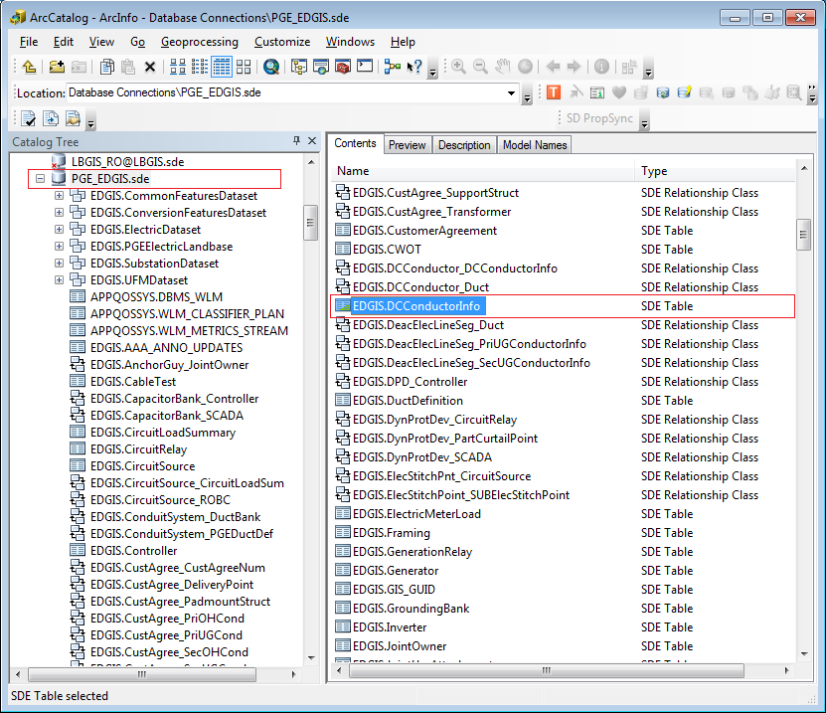

1. In “Fields” tab, locate CONDUCTORTYPE field and select.

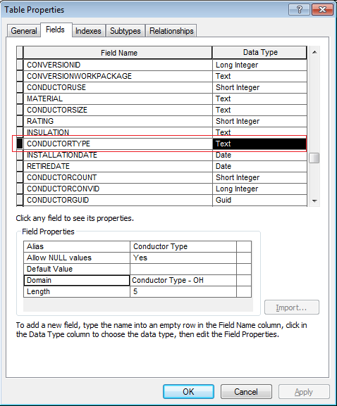

1. Change the “Domain” in the “Field Properties” to “Conductor Type – DC”.

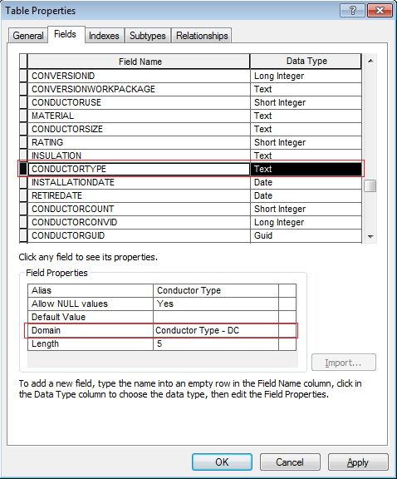

1. Click OK to accept.

# 17979 - Clean-up unused UFM features/fields

1. In the UFM Dataset, locate the “EDGIS.UFMWall” feature class. Right click and select “Properties…”.

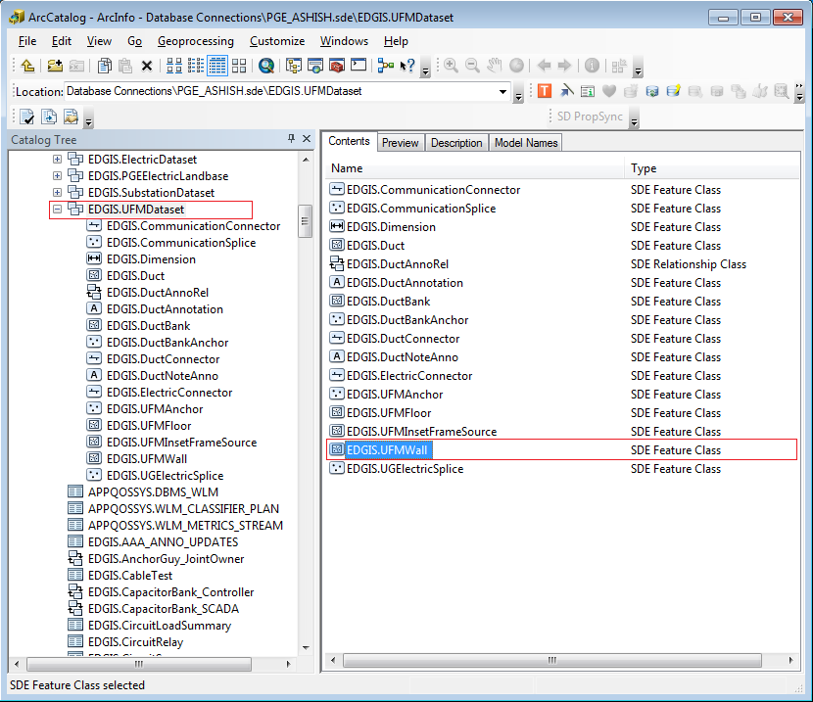

1. In “Fields” tab, select DIRECTION field and press “**Delete**” key.

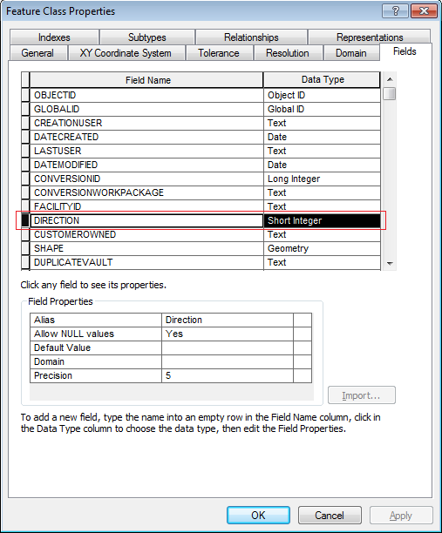

1. Click OK to accept.
2. In the Electric Dataset, locate the “EDGIS.CrossSectionDirAnno” feature class. Right click and select “**Delete**”.

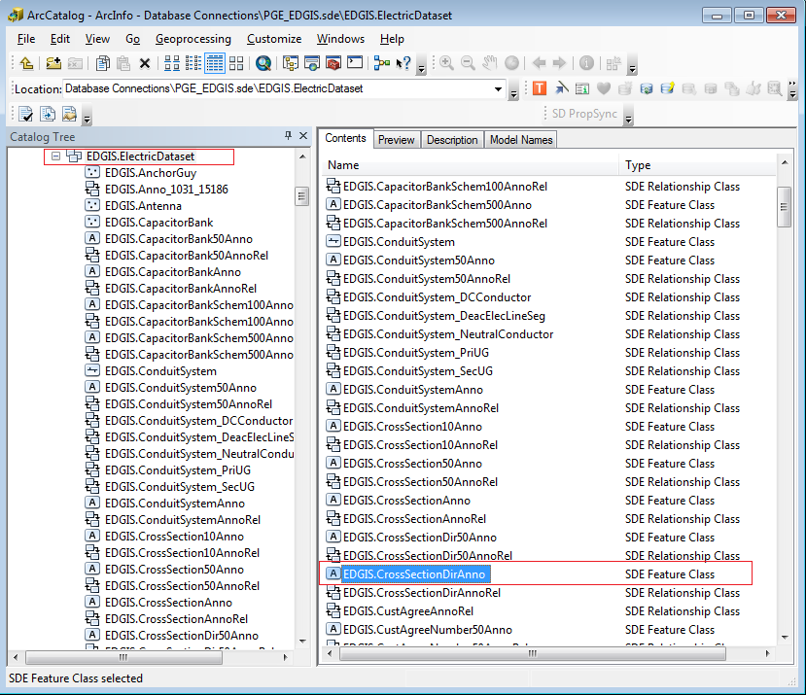

1. Click “Yes” when prompted.

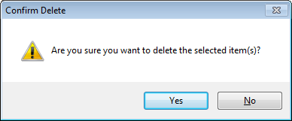

1. In the Electric Dataset, locate the “EDGIS.CrossSectionDir50Anno” feature class. Right click and select “**Delete**”.

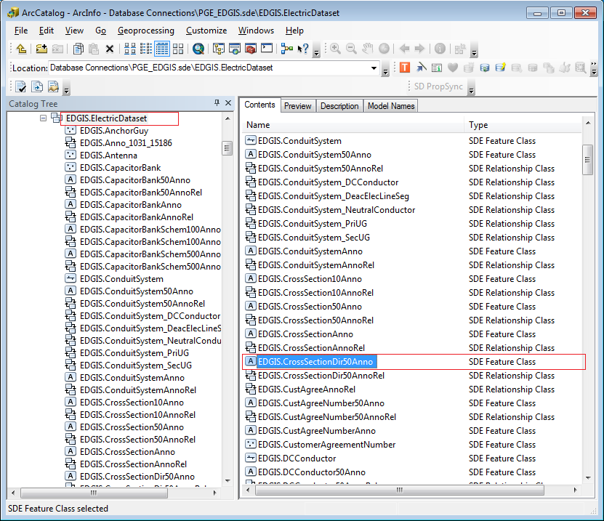

1. Click “Yes” when prompted.



1. In the UFM Dataset, locate the “EDGIS.DuctBank” feature class. Right click and select “Properties…”.

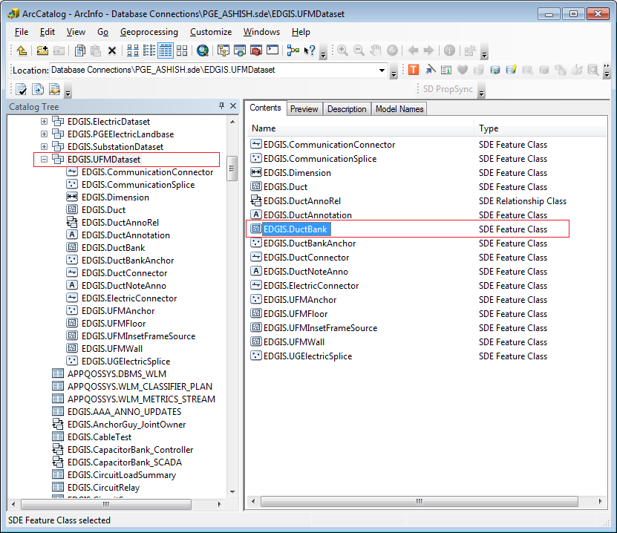

1. In “Fields” tab, select CONDUITSYSTEMOBJECTID field and press “**Delete**” key.

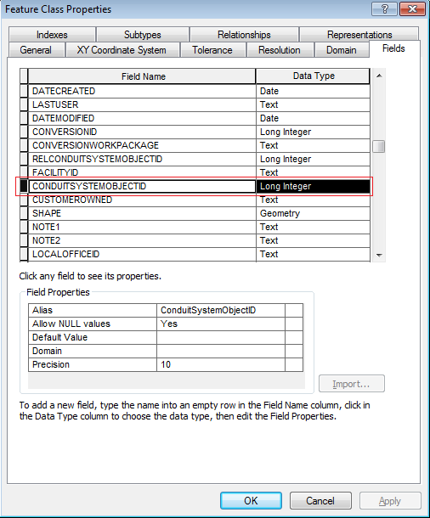

1. Click OK to accept.

# 17981 - UFM Display Fields

1. In the UFM Dataset, locate the “EDGIS.Duct” feature class. Right click and select “ArcFM Properties Manager”.

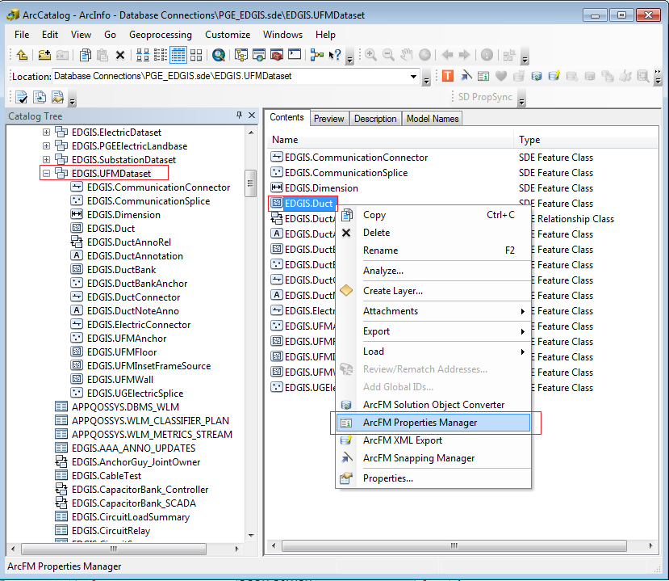

1. In “Field Display” tab, select DUCTPOSITION in the “Primary Display Field” dropdown.

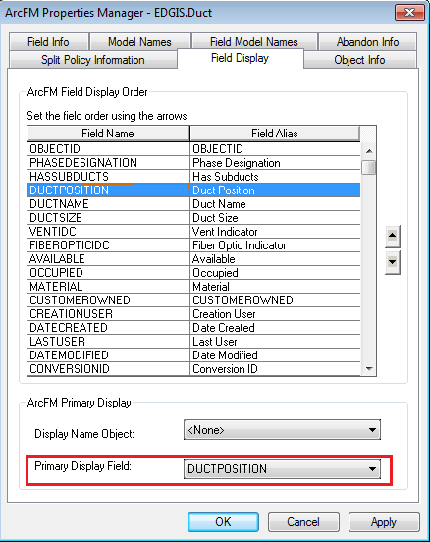

1. Click OK to accept.

# Create DC Service Location Feature Class

1. Copy the Python script “Add_dcserviceloc_to_db.py” locally.
2. Edit the script to point to the correct SDE file using the EDGIS user.
3. Execute the script in a command prompt.
4. Copy the output into a file and attach it to the TFS ticket for this request.
5. In ArcCatalog, double click on the new DCServiceLocation feature class.
6. Select the Fields tab and add a Subtype field as follows:

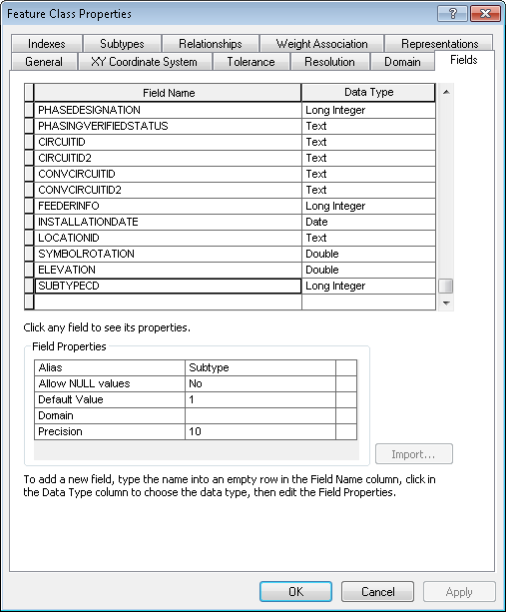

1. On the Subtypes tab, set the subtype field as SUBTYPECD and add a new subtype with Code = 1 and Description = “DC Service Location”.

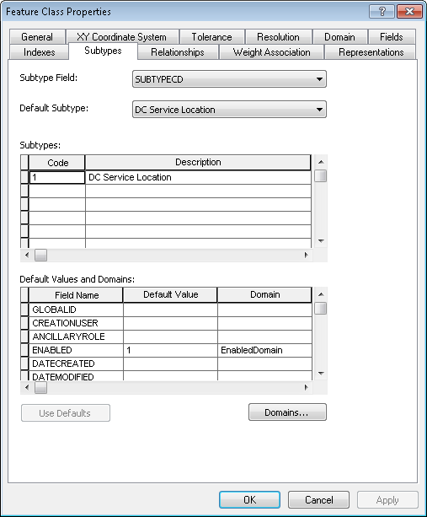

1. Click on OK to save the changes.
2. Right-click on the new DC Service Location feature class and select ‘ArcFM Snapping Manager’.
3. Assign the DC Service Location to snap to the end of a DC Conductor.

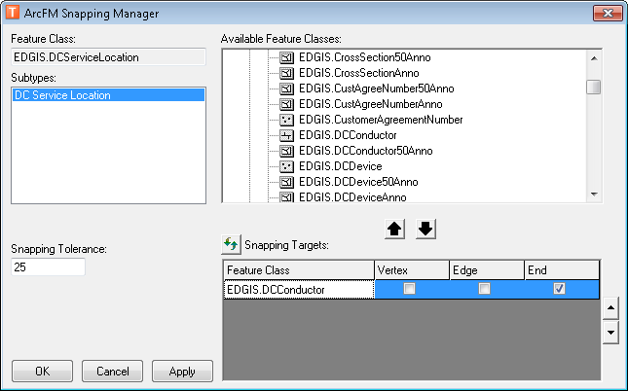

# Create Relationship Fields and New Subtype for Service Point

1. Copy the Python script “Add_fields_and_subtype_to_service_point.py” locally.
2. Edit the script to point to the correct SDE file using the EDGIS user.
3. Execute the script in a command prompt.
4. Copy the output into a file and attach it to the TFS ticket for this request.

# Create Relationship Field For DCRectifier

1. Copy the Python script “Add_field_to_dc_rec.py” locally.
2. Edit the script to point to the correct SDE file using the EDGIS user.
3. Execute the script in a command prompt.
4. Copy the output into a file and attach it to the TFS ticket for this request.

# Create 1-M Relationship between DC Service Location and Service Pt Table

1. Right click the database and select New->Relationship Class.
2. Fill out the screens as below:  
   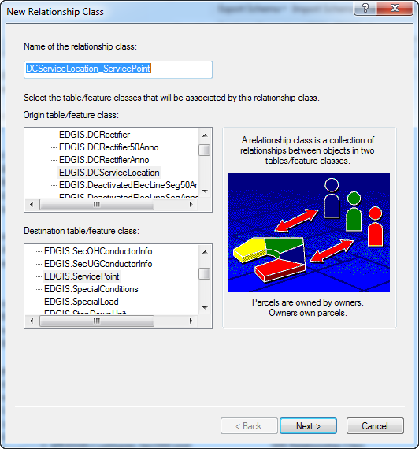  
   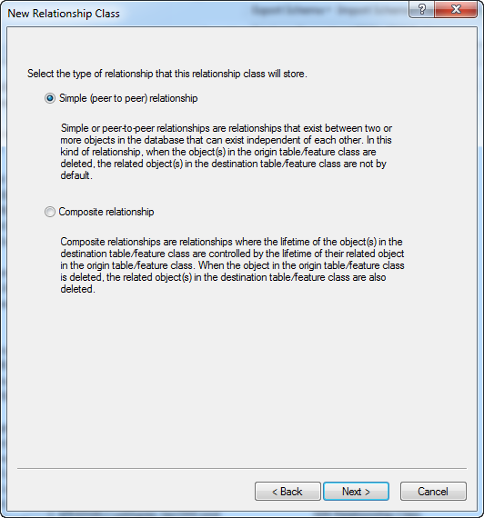  
   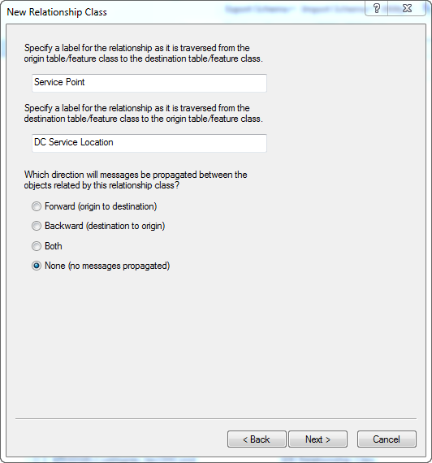  
   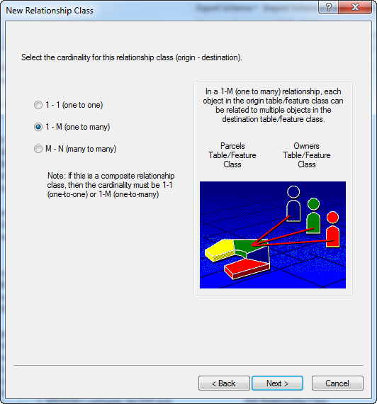  
   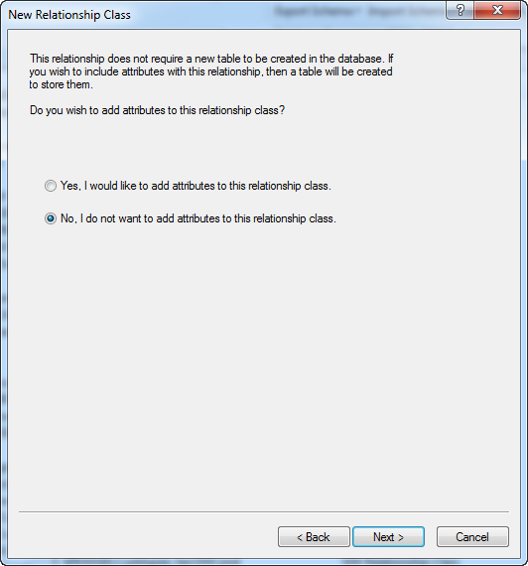  
   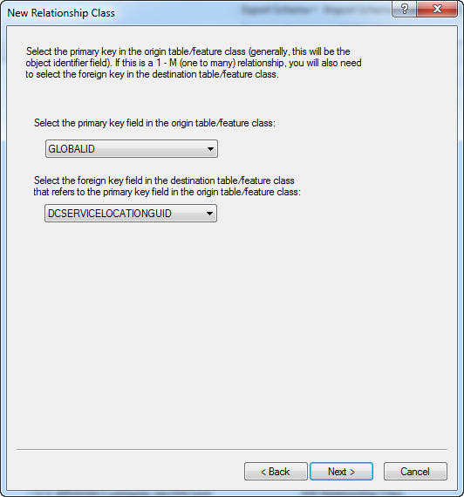
3. Verify the relationship properties:  
   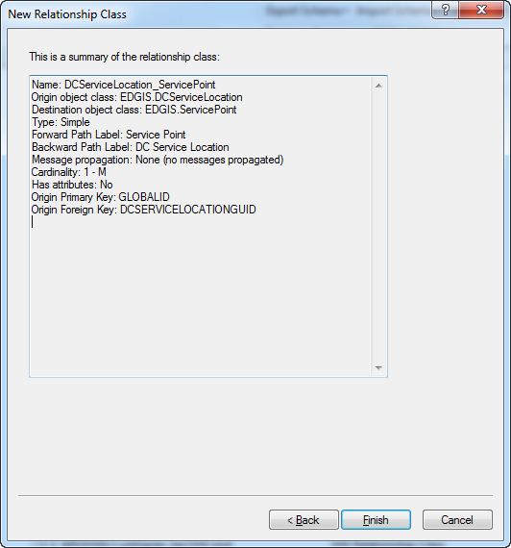
4. Click Finish.

# Create Relationship Between DC Rectifier and Service Point table

1. Right click the database and select New->Relationship Class.
2. Fill out the screens as below:  
   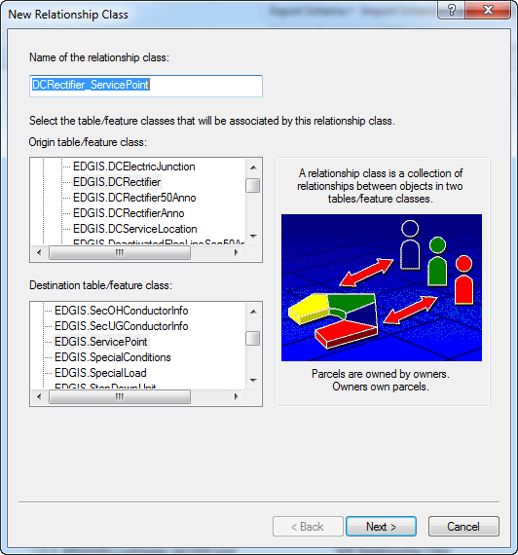  
   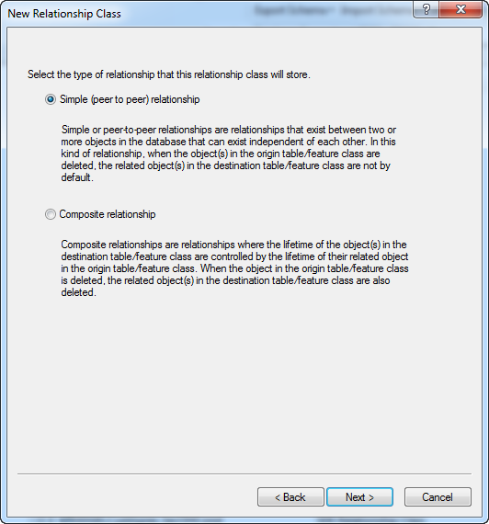  
   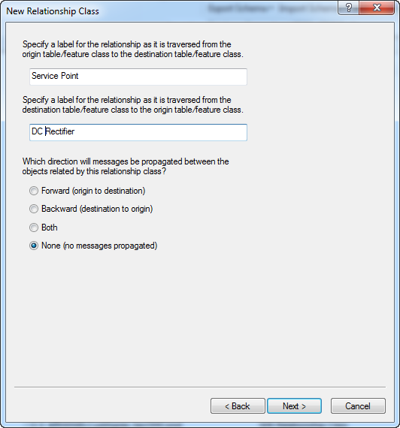  
   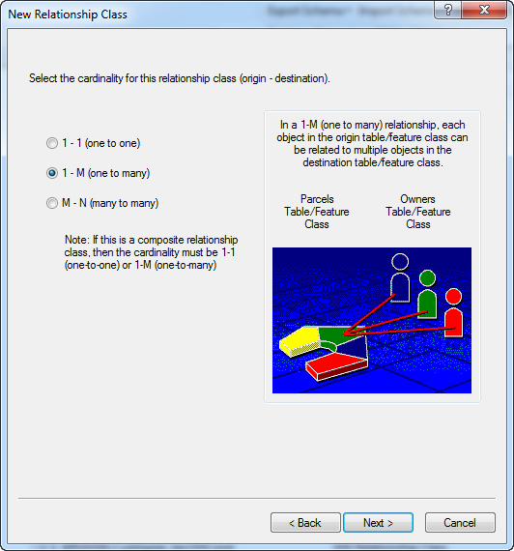  
   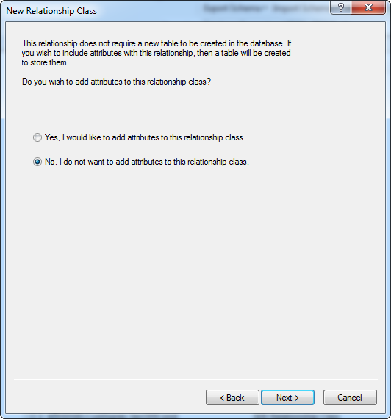  
   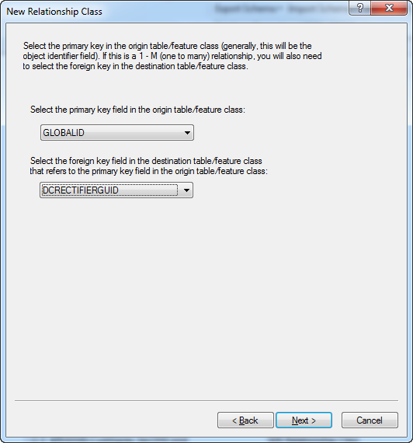
3. Review the summary of changes and click Finish.  
   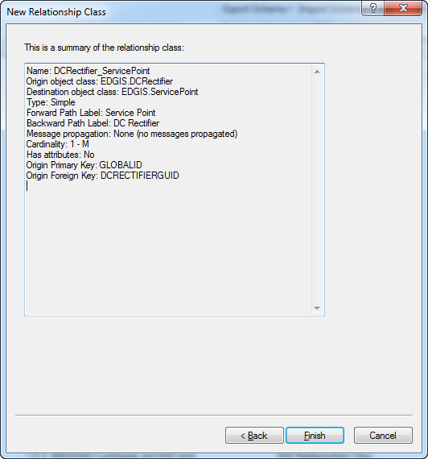

# Create Relationship Between Transformer and DCRectifier

1. Right click the ElectricDataset and select New->Relationship Class.
2. Fill out the screens as below:  
   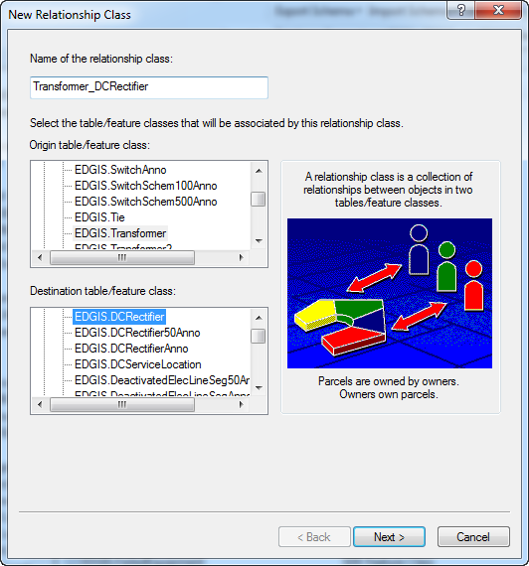

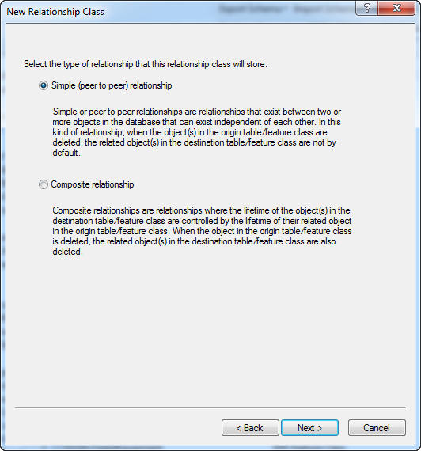

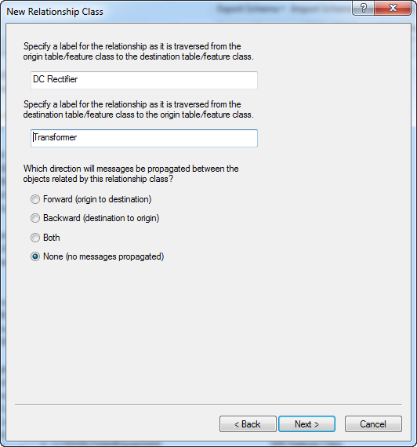

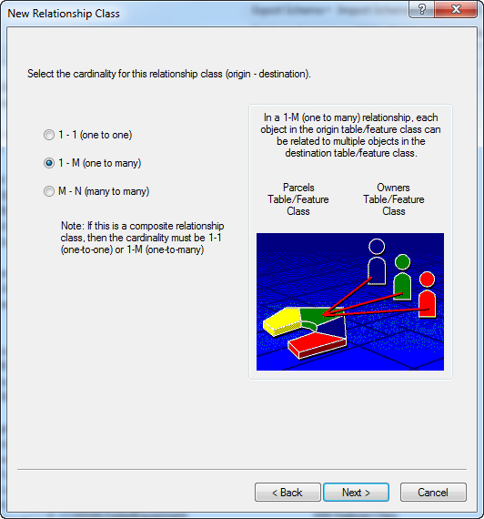

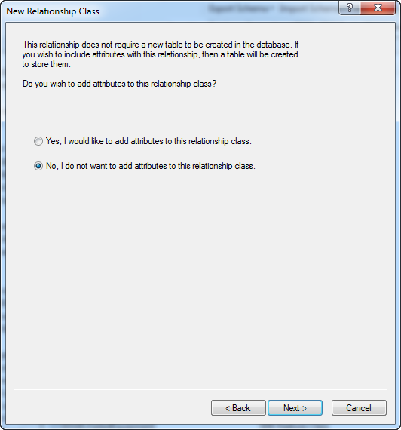

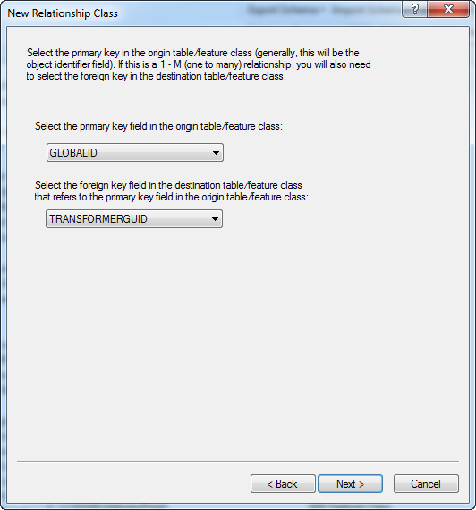

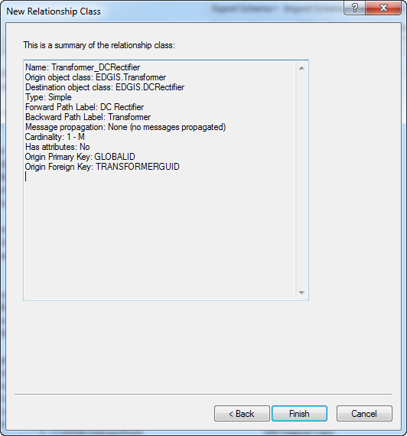

# Configure Relationship Cardinalities

1. Double click the DCServiceLocation_ServicePoint relationship.
2. In the Rules tab, click the EDGIS.DCServiceLocation in the Origin box.
3. Check all rows in the Destination box:  
   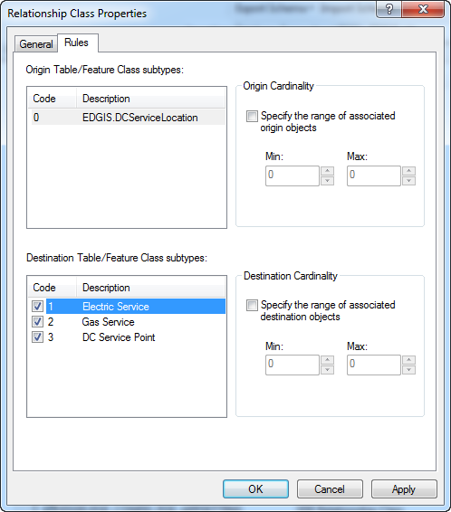
4. Select Electric Service and check the “Specify…” box on the right for both Origin and Destination. Min and Max should be set to 0 for both.  
   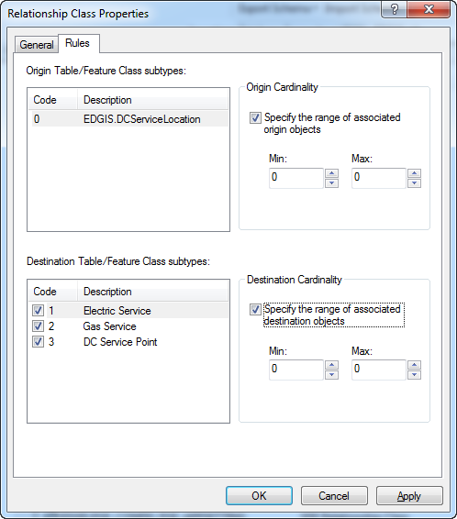
5. Repeat the previous step for Gas Service.
6. Select DC Service Point and check both boxes.
7. Set the origin min: 0, max: 1.
8. Set the destination min: 0, max: 9999.  
   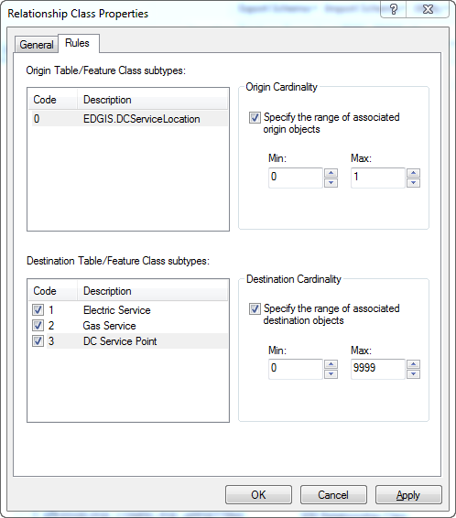
9. Select OK to accept.
10. Double click the DCRectifier_ServicePoint relationship class.
11. In the Rules tab, repeat the above steps. In the end, everything but the DC Service Point subtype will have a min=0 and max=0. The DC Service Point will have min=0, max=1 for the origin and min=0, max=9999 for the destination.  
    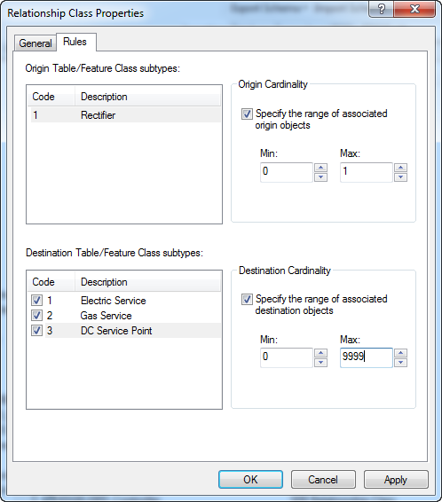

# Remove DC Rectifier->CircuitSource Relationship class

1. Right-click the EDGIS.Rectifier_CircuitSource relationship class

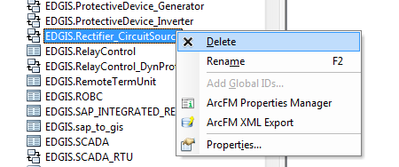

1. Select Delete
2. Click ‘Yes’ when asked ‘Are you sure you want to delete the selected item(s)?’

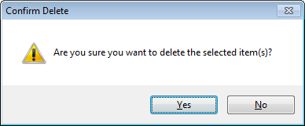

# Add DC to Electric Network

1. Execute the latest Electric Network Rebuild document.

# 17980 - Change Network Protector Annotation Expression

1. Double click the NetworkProtectorAnno feature class and select the Annotation Classes tab.
2. Select ‘Expression’ for the Default annotation class.
3. Select all of the expression text and delete it.
4. Paste in the following:  
   [OPERATINGNUMBER]  
   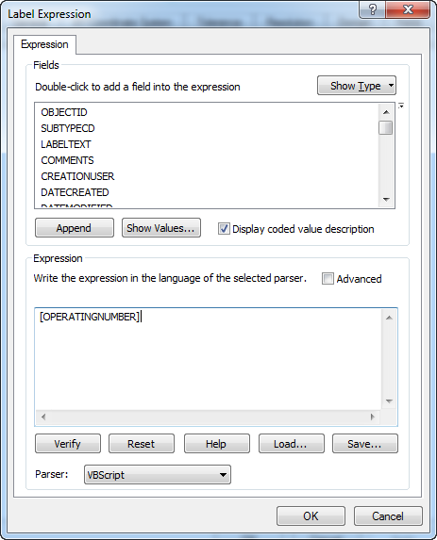
5. Select OK and OK again to accept changes.
6. Repeat the above steps for NetworkProtector50Anno.

# 17982 - Add domain value to Duct Shape domain

1. Right click the database and select Properties.
2. In the Domains tab, scroll to the Duct Shape domain.
3. Add the following code/value to it:  
   TN/Tunnel  
   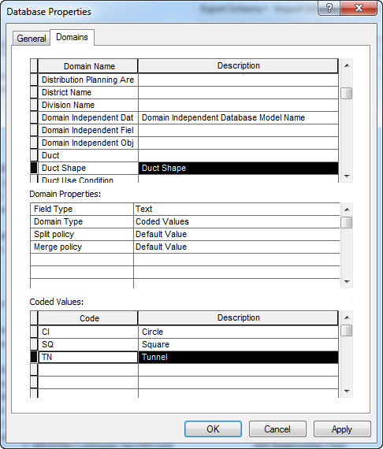
4. Click OK to accept the changes.

# 18258 – Remove GroundingSwitch subtype on TransformerDevice

1. In the root of the database, double click TransformerDevice.
2. Select the Subtypes tab.
3. Highlight the GroundingSwitch subtype and select Delete  
   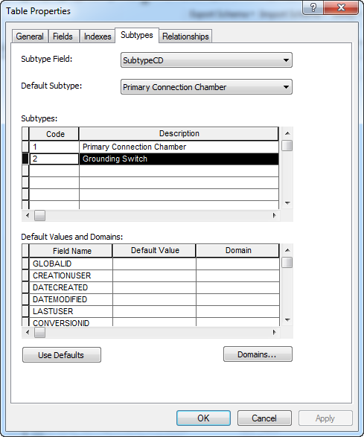
4. Click Apply to accept changes.  
   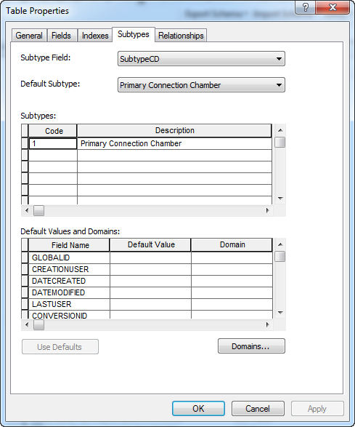

# Data Model Version Table

**Database Configuration:**

1. Open SQL Plus.
2. Log in using the same server and user as was used in section 2.  
     
   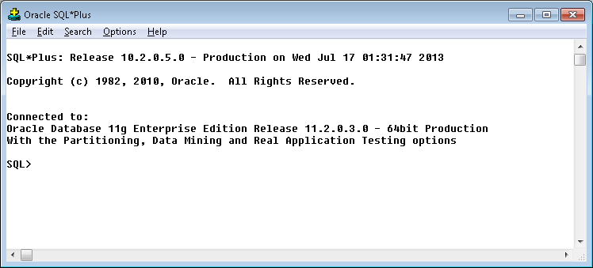
3. Run the SQL below:

update pgedatamodelversion set currentidc='N' where currentidc='Y';

insert into pgedatamodelversion (OBJECTID, CURRENTIDC, DATEAPPLIED, APPLIEDBYPERSONNAME, MODELVERSION) values (**INSERT NEXT VALID ID**,'Y',sysdate,'**<INSERT TEAM MEMBER DONE BY>**','**<INSERT DM VERSION>** GOLD **CR<INSERT CR NUMBER>**');

commit;

# Known Issues

<Please List any other issues encountered here while following the document>